Paige Millis-Wight
STP 429
Dr. Schneider
April 28, 2024
Thank you for the semester, I look forward to DAT 431 :)
Abstract
The goal of this paper is to lay out the analysis of statistical data collected on the end of day prices of RCL (Royal Caribbean Line) stock based on the end of day prices of other stocks in the same market. The best linear regression model can be used to predict RCL’s end of day stock. The initial independent variables (company stocks) being considered are: BBY, BWA, CCL, EBAY, EXPE, GRMN, HAS, KMX, LOW, NCLH, NKE, PHM, TSLA, and ULTA.
The first step in the analysis is an exploration of the chosen independent variables. These variables have been chosen based on a series of SAS variable selection procedures. Not every variable has a normal distribution although the total number of outliers appears low. These variables were then individually correlated with the independent variable to confirm that they contributed to the model.
After identifying a potentially significant model we ran a correlation matrix between all numeric variables to determine whether an interaction term would be beneficial. After finding that CCL and EXPE are highly related we made an interaction plot to confirm the possible relevancy of an interaction term. Then we looked at the residual plots accompanying the model; although the plot itself looks relatively scattered, it is obvious that the residual fit plot is not following a linear pattern. To attempt to combat this we added a second order variable based on BBY. We then added these variables to the model and conducted a nested F-test to determine whether either of them provided prediction power to our model. The F-test came back insignificant so neither of these variables were added to the final model.
After testing a potential interaction term and a potential second order term we wanted to conduct tests for multicollinearity and conduct more in-depth examination of the model’s health. By finding the variance inflation or VIF for each variable we were able to remove those causing multicollinearity that could be masking the other variables in the model (PHM, GRMN, CCL). Then we looked at the partial residual plots for the variables in our pared down model. Some variables hug the line better than other variables but nothing looks extremely amiss. Variable transformations could possibly help with this.
Once the model looked ok I ran a final proc reg and removed the only variable with an insignificant p-value (t-test). This did not affect the model much but it did increase the F-value by about 100 so I did not add HAS back in. After the final variables were confirmed I ran more tests on the model. The studentized residual plot revealed that only 3% of the observations in our model rest above or below two standard deviations from the mean. This confirmed the acceptability of the model.
Finally, a linear regression equation was generated and interpreted based on the model: RCL (hat) = 72.94115 + 0.31356(BBY) - 1.57924(BWA) - 0.57643(EBAY) + 0.44319(EXPE) + 0.24021(KMX) + 0.16510(LOW) + 2.64471(NCLH) - 0.20936(NKE) - 0.06695(TSLA) - 0.06111(ULTA) . All regression analysis implies that this is an adequate model. Future testing regarding which corporate sector has the most influence on stocks representing Hotels, Resorts, and Cruise Lines would be interesting. The results from this testing could provide a more generalized way to find relationships between end of day stock prices. If one sector more heavily and consistently influences another sector this could be helpful to know.
Data
The data consists of daily stock prices from 4/1/23 - 3/31/34 for all Consumer Discretionary components of the S&P 500. We were initially observing all 51 components. From this list we wanted to identify which components had the most correlation with our chosen independent component, RCL (Royal Caribbean Cruise Line). To do this we ran a criterion panel and individual selection processes including all components. These iteratively checked the adequacy of models composed of different/different numbers of components and returned, on average, fourteen potentially significant ones that together formed a significant model. Once these variables were identified we ran individual tests to identify their distributions and outliers before paring them down to improve the model. It should also be noted that because they were returned by a variable selection function they all have a p-value that is less than 0.05.
The first chosen component is RCL or Royal Caribbean Cruise Lines, this is our dependent variable and it lives in Hotels, Resorts, and Cruise Lines. The histogram and probability plot show that the distribution of RCL is relatively normal within a certain scope. Beyond this scope it appears as if the distribution has some sort of curvilinear trend. This means that when predicting based off of this data we need to be very sure to only predict within our bounds. The box and whisker plot for RCL implies that there do not appear to be any outliers (fig.17).
The first chosen independent component considered is BBY or Best Buy, this stock lives in Computer and Electronics Retail . The histogram and probability plot show that the distribution of BBY is relatively normal within approximately the same scope as RCL (+/- 2s from mean). Beyond this scope it appears as if the distribution has some sort of curvilinear trend. This means that when predicting based off of this data we need to be very sure to only predict within our bounds. The box and whisker plot for BBY implies that there do not appear to be any outliers. The scatter plot generated between RCL and BBY implies some sort of weak positive linear correlation; this is confirmed by the sign of the parameter estimate and the value of R between these two points (fig.18)(fig.19)(fig.BBYR).
The second chosen independent component considered is BWA or BorgWarner, this stock lives in Automotive Parts and Equipment. The histogram and probability plot show that the distribution of BWA is kind of normal but also not really at all. This data shows an obvious curvilinear trend. This means that its predictive power is limited within a linear regression format but it can still add to the model. The box and whisker plot for BWA implies that there do not appear to be any outliers. The scatter plot generated between RCL and BWA implies the existence of some moderately strong negative linear correlation; this is confirmed by the sign of the parameter estimate and the value of R between these two points (fig.20)(fig.21)(fig.BWAR).
The third chosen independent component considered is CCL or Carnival Cruise Line, this stock lives in Hotels, Resorts, and Cruise Lines. The histogram and probability plot show that the distribution of CCL is kind of normal, better than BWA, but also not really at all. This data shows an obvious curvilinear trend. This means that its predictive power is limited within a linear regression format but it can still add to the model. The box and whisker plot for CCL implies that there do not appear to be any outliers. The scatter plot generated between RCL and CCL implies a strong positive linear correlation; this is confirmed by the sign of the parameter estimate and the value of R between these two points (fig.22)(fig.23)(fig.CCLR).
The fourth chosen independent component considered is EBAY, this stock lives in Broadline Retail. The histogram and probability plot show that the distribution of EBAY is kind of normal but mostly not really at all. This data shows an obvious curvilinear trend. This means that its predictive power is limited within a linear regression format but it can still add to the model. The box and whisker plot for EBAY implies that there are an array of upper outliers and a few lower outliers.do not appear to be any outliers, this isn’t wonderful. The scatter plot generated between RCL and EBAY implies some sort of weak positive linear correlation; this is confirmed by the sign of the parameter estimate and the value of R between these two points (fig.24)(fig.25)(fig.EBAYR).
The fifth chosen independent component considered is EXPE, or Expedia, this stock lives in Hotels, Resorts, and Cruise Lines. The histogram and probability plot show that the distribution of EXPE is kind of normal in an even smaller scope than BBY. This data shows an obvious curvilinear trend. This means that its predictive power is limited within a linear regression format but it can still add to the model. The box and whisker plot for EXPE implies that there do not appear to be any outliers. The scatter plot generated between RCL and EXPE implies that there exists a strong positive linear correlation; this is confirmed by the sign of the parameter estimate and the value of R between these two points (fig.26)(fig.27)(fig.EXPER).
The sixth chosen independent component considered is GRMN or Garmin, this stock lives in Consumer Electronics. The histogram and probability plot show that the distribution of GRMN is not really normal at all. This data shows an obvious curvilinear trend. This means that its predictive power is limited within a linear regression format but it can still add to the model. The box and whisker plot for GRMN implies that there do not appear to be any outliers. The scatter plot generated between RCL and GRMN implies that there exists a relatively strong positive linear correlation; this is confirmed by the sign of the parameter estimate and the value of R between these two points (fig.28)(fig.29)(fig.GRMNR)..
The seventh chosen independent component considered is HAS, this stock lives in Leisure Products. The histogram and probability plot show that the distribution of HAS is actually pretty good looking all things considered.. This data shows an obvious curvilinear trend but hugs the normal quantile lines better than most of the other variables. This means that its predictive power is limited within a linear regression format but it can still add to the model, perhaps even more so than its less normal counterparts. The box and whisker plot for HAS implies that there do not appear to be any outliers. The scatter plot generated between RCL and HAS implies some sort of weak negative linear correlation; this is confirmed by the sign of the parameter estimate and the value of R between these two points (fig.30)(fig.31)(fig.HASR).
The eighth chosen independent component considered is KMX or CarMax, this stock lives in Automotive Retail. The histogram and probability plot show that the distribution of KMX is kind of normal, it looks very similar to the distribution of HAS. This means that its predictive power is limited within a linear regression format but it can still add to the model, perhaps even more so than its less normal counterparts. The box and whisker plot for KMX implies that there do not appear to be any outliers.. The scatter plot generated between RCL and KMX implies some sort of weak positive linear correlation; this is confirmed by the sign of the parameter estimate and the value of R between these two points (fig.32)(fig.33)(fig.KMXR).
The ninth chosen independent component considered is LOW or Lowe’s, this stock lives in Home Improvement Retail. The histogram and probability plot show that the distribution of LOW is pretty normal within 2s of the mean. The histogram and probability plot show that the distribution of LOW is relatively normal within approximately the same scope as RCL (+/- 2s from mean). Beyond this scope it appears as if the distribution has some sort of curvilinear trend. This means that when predicting based off of this data we need to be very sure to only predict within our bounds. The box and whisker plot for LOW implies that there exists a single upper outlier. The scatter plot generated between RCL and LOW implies that there exists some moderately strong positive linear correlation; this is confirmed by the sign of the parameter estimate and the value of R between these two points (fig.34)(fig.35)(fig.LOWR).
The tenth chosen independent component considered is NCLH or Norwegian Cruise Line Holding, this stock lives in Hotels, Resorts, and Cruise Lines. The histogram and probability plot show that the distribution of NCLH is kind of normal but not really. It does look better than some of the other components but there is a distinct curvilinear trend. The box and whisker plot for NCLH implies that there do not appear to be any outliers. The scatter plot generated between RCL and NCLH implies that there exists some moderately strong positive linear correlation; this is confirmed by the sign of the parameter estimate and the value of R between these two points (fig.36)(fig.37)(fig.NCLHR).
The eleventh chosen independent component considered is NKE or Nike, this stock lives in Apparel, Accessories, and Commercial Goods. The histogram and probability plot show that the distribution of NKE is kind of normal but has a distinct curvilinear trend This means that NKE could still contribute to the model but it might not be best represented by a linear regression model. The box and whisker plot for NKE implies that there exists an array of upper outliers. The scatter plot generated between RCL and NKE implies some sort of moderately weak negative linear correlation; this is confirmed by the sign of the parameter estimate and the value of R between these two points (fig.38)(fig.39)(fig.RNKE).
The twelfth chosen independent component considered is PHM or PulteGroup, this stock lives in Home Building. The histogram and probability plot show that the distribution of PHM is not consistently normal and has a distinct curvilinear trend. The box and whisker plot for PHM implies that there do not appear to be any outliers. The scatter plot generated between RCL and PHM implies that there exists a very strong positive correlation, this is confirmed by the sign of the parameter estimate and the value of R^2 between these two points (fig.40)(fig.41)(fig.PHMR).
The thirteenth chosen independent component considered is TSLA, this stock lives in Automobile Manufacturers. The histogram and probability plot show that the distribution of TSLA is relatively normal within approximately the same scope as RCL (+/- 2s from mean). The data does appear primarily curvilinear though, this means that while it might contribute to our model it may be best represented by a non-linear model. The box and whisker plot for TSLA implies that there do not appear to be any outliers. The scatter plot generated between RCL and TSLA implies some sort of really weak positive linear correlation; this is confirmed by the sign of the parameter estimate and the value of R^2 between these two points (fig.42)(fig.43)(fig.TSLAR).
The final chosen independent component considered is ULTA, this stock lives in Other Speciality Retail. The histogram and probability plot show that the distribution of ULTA is relatively normal within approximately the same scope as RCL (+/- 2s from mean) but also not really, as there appears a distinct curvilinear trend. The box and whisker plot for ULTA implies that there do not appear to be any outliers. The scatter plot generated between RCL and ULTA implies some sort of weak positive linear correlation; this is confirmed by the sign of the parameter estimate and the value of R^2 between these two points (fig.44)(fig.45)(ULTAR).
After finding the best first order model we wanted to look for potential interaction terms and second order terms. These were identified and tested using various SAS procedures. To perform this analysis we had to generate a new data set containing the potential interaction and second order terms. Their significance was then determined and they were not added to our model. Once this was confirmed we worked to reduce any multicollinearity in the model using various SAS procedures. This led to us removing three additional variables from our model. Then we re-ran a linear regression model on the data and removed one component that was no longer returning a significant p-value to reach our final model.
Methodology
Before beginning our analysis we had to find how many observations we were working with and we had to identify the variable’s taxonomy. To do this we ran proc contents in SAS (fig. 01)(fig.02). After we established what our dataset looked like we ran a proc reg on all 51 components including the stepwise selection function (fig.03). This function ran through all potential models and eliminated or added variables based on how those terms impacted the R^2 and C(p) of the model. The stepwise regression function returned 18 variables with each of them significant at the 0.05 level (fig.04). We wanted to see if other variable selection methods would return a similar “best model”.
The next variable selection method we used was R^2. This method returned the five best models containing 8-20 variables (fig.05). The R^2 does not appear to increase dramatically at any point after approximately 9 variables are included in the model (fig.06). This implies that the best model probably contains around 9 variables. We then wanted to use the R^2 adj variable selection method (fig.07). The highest R^2 adj value we can achieve is 0.9948 with approx. 35 variables (fig.08). We may not need to aim so high but at least we know we can achieve a good model. We also used the variable selection methods that are based on C(p) (fig.09). This method focuses on minimizing the mean square error of the model and regression bias. The smallest achievable C(p) is approx. 21, this occurs with 29 variables (fig.10). The final selection method we used before looking at them together utilizes the press criterion to determine a good model. This method uses the predictive sum of squares to identify which model has the most predictive power. This method cannot be run in a proc reg and must be within a proc glmselect (fig.11). The optimal press criterion is the smallest one possible. This was identified with a fourteen variable model (fig.12).
We then used the GLMSELECT procedure to compare the variable selection methods (fig.13). The criterion panel implied that, in general, each selection method agreed on a 20 variable model (fig.14). The final selection used many more stats to produce a fourteen variable model (fig.15). We proceeded using this model for the rest of the analysis.
After identifying our variables we ran proc univariate functions which graphed a histogram and box-and-whiskers plots from which we were able to discern distribution and potential outliers; we simultaneously performed a proc sgplot function to get an idea of what the correlation between our independent variables and wins looks like (fig.16)(fig.17).
Once we had identified and were familiar with our dataset and data we wanted to test if an interaction term or second order term would benefit the model. Starting with the interaction term, we ran a proc corr between all numeric variables in the dataset. CCL and EXPE appeared highly, and significantly correlated (fig.46)(fig.47). To confirm this we created an interaction plot using proc glm/plm. The interaction plot had non-parallel lines so we added a CCL_EXPE variable into a second data set to be tested for significance (fig.48)(fig.49). We then ran a proc reg function to look at the residual plot for our variables, it did not appear random so we decided to create and test a second order term. BBY_SQUARED was added to the new data set (fig.50)(fig.51). Then a nested F-test was performed including both new variables. The nested F-test did not return significantly which implies the inclusion of these variables is not necessary and they were not added to the model (fig.52)(fig.53).
After finding the best model we ran a proc reg test including VIF. The stocks with VIF > 10 were then removed one at a time until there was no potential for one variable to mask another (fig.54)(fig.55). Then we ran residual plots using proc reg to determine whether there appeared to be any heteroscedasticity or unequal variances in the model. You want each variable to vary equally from the LSRL so this is not ideal if it shows up. The residual plots were not completely linear, which would imply equal variances but they looked pretty good so I decided to leave it alone (fig.56)(fig.57). Finally we ran a proc reg test that included and printed all additional stats. We did this to confirm that the studentized residual plot did not show an unreasonable percentage of outliers (fig.58)(fig.59). After checking that everything in the model looks good and removing a final variable that did not have a significant p-value, we used our data to find the least squares regression line equation (fig.60).

Results
Model | F-value | CoeffVar | R^2 (adj) | Overall Adequacy
RCL(hat) = B0 + B1(BBY) + B2(BWA) + B3(CCL) + B4(EBAY) + B5(EXPE) + B6(GRMN) + B7(HAS) + B8(KMX) + B9(LOW) + B10(NCLH) + B11(NKE) + B12(PHM) + B13(TSLA) + B14(ULTA) + error | 2506.85 (<0.0001) | 1.63617 | 0.9930 | Great but:  Interaction terms present, residual plot is not random, multicollinearity is unchecked
RCL(hat) = B0 + B1(BBY) + B2(BWA) + B3(CCL) + B4(EBAY) + B5(EXPE) + B6(GRMN) + B7(HAS) + B8(KMX) + B9(LOW) + B10(NCLH) + B11(NKE) + B12(PHM) + B13(TSLA) + B14(ULTA) + B15(CCL)(EXPE) + B16(BBY^2) + error | 2183.56 (<0.0001) | 1.64045 | 0.9929 | Still Great but: New terms probably not necessary (no big change in model), multicollinearity is unchecked
RCL(hat) = B0 + B1(BBY) + B2(BWA) + B4(EBAY) + B5(EXPE) + B7(HAS) + B8(KMX) + B9(LOW) + B10(NCLH) + B11(NKE) + B13(TSLA) + B14(ULTA) + error | 1181.70 (<0.0001) | 2.67405 | 0.9813 | Looking Good: no more multicollinearity but one of my p-values is insignificant
RCL(hat) = B0 + B1(BBY) + B2(BWA) + B4(EBAY) + B5(EXPE) + B8(KMX) + B9(LOW) + B10(NCLH) + B11(NKE) + B13(TSLA) + B14(ULTA) + error | 1291.56 (<0.0001) | 2.68238 | 0.9811 | Still looks really good: all p-values significant and multicollinearity checked

The first row details information pertaining to the fourteen variable model returned by our various selection processes. This model returned an F-value of 2506.85 which is highly significant. This means that we have enough evidence to reject the null hypothesis that B1-14=0 and instead support the conclusion that at least one of the variables in this model contributes to our ability to predict the price of RCL. The coefficient of variation (CV) in this model is 1.63. This is really good, it means that the data in this model varies very slightly from the LSRL, implying strength in the predictive power of our LSRL. Any CV value less than or equal to approx. 10 contributes to the implication of a strong LSRL. Finally the R^2 adj is 0.9930. This means that approximately 99.3% of the variation in RCL can be accounted for by the variables in our model. This is basically as mouth-watering as you can get in terms of an R^2 adj value. The model stats look amazing but we still need to test whether the addition of an interaction and second order term is necessary.
These were added into the model tested in row 2. The stats look good but have not significantly improved. This implies that the additional variables are probably not necessary. This is confirmed by a nested f-test which returned an insignificant f-value of 0.47. This means that we do not have enough evidence to reject the null hypothesis that the addition of an interaction or second order variable was beneficial to the model (B15=B16=0). After confirming that these terms were unnecessary we removed them and tested the original fourteen-variable model for multicollinearity.
Three variables, PHM, GRMN, and CCL returned VIF values of approx. 46, 28, and 27 respectively. A variance inflation value that is higher than 10 implies that the corresponding variable is correlated so highly with another that their relationship is hiding the true nature of the relationship between our chosen dependent and independent variables. These variables were subsequently removed and the proc reg function was performed resulting in the data from row 3. The key statistics still look good and the model is now multicollinearity-proof. However, upon closer inspection there is a variable, HAS, that does not return a significant p-value. This means that we have enough evidence to support the null hypothesis that B5=0 and reject the idea that B5, which determines how much HAS impacts RCL, has any value. This means that there is not enough evidence to conclude that this variable has any effect on RCL and it can be removed from the model.
The final model represented in row 4 reflects the final 10 variables. The model returns a significant F-value of 1291.56, it should also be noticed that the F-value improved by approx. 100 points simply from the removal of HAS. A significant F-value speaks highly to the adequacy of the model. The model returns a CV of 2.68 which is still much lower than 10 (good). It also has an R^2 (adj) value of 0.9811. This means that 98% of the variance in RCL can be explained by our variables; this is very, very good. It appears that we have our best model but we want to further scrutinize where we landed. To do this we looked at the partial residual plots for each variable in the model. In an ideal model the data for each variable would follow a linear pattern. Although some of the plots look more linear than others none of them look entirely random or blatantly non-linear. I tried various transformations on both the independent and dependent variables to try to straighten these plots out but there were no transformations that significantly improved the data. After concluding that the partial residuals looked acceptable I ran a test to look at the studentized residual plot and the cooksd. Although the cooksd contains some outliers the studentized residual plot has highlighted any problematic residuals associated with them. Only 3% of observations are problematic; this is acceptable. All relevant residual and fit plots have been analyzed and they do not significantly question the validity of our model. This implies that we have reached the best possible model with row 4.
Our best model: RCL (hat) = 72.94115 + 0.31356(BBY) - 1.57924(BWA) - 0.57643(EBAY) + 0.44319(EXPE) + 0.24021(KMX) + 0.16510(LOW) + 2.64471(NCLH) - 0.20936(NKE) - 0.06695(TSLA) - 0.06111(ULTA) implies that if none of our independent variables were factors then we would expect the daily RCL stock price to be approx. $72.94. We know that for every one unit increase in BBY stock price we expect an $0.31 increase in RCL. For every one unit increase in BWA we expect an $1.57 decrease in RCL. For every one unit increase in EBAY we expect an $0.57 decrease in RCL. For every one unit increase in EXPE we expect an $0.44 increase in RCL. For every one unit increase in KMX we expect an $0.24 increase in RCL. For every one unit increase in LOW we expect an $0.16 increase in RCL. For every one unit increase in NCLH we expect an $2.65 increase in RCL. For every one unit increase in NKE we expect an $0.21 increase in RCL. For every one unit increase in TSLA we expect a $0.07 decrease in RCL. For every one unit increase in ULTA we expect a $0.06 decrease in RCL.
Conclusion
We can conclude that between 4/1/23 - 3/31/34 the daily stock price for Royal Caribbean Cruise Line can best be predicted by the daily prices of BestBuy, BorgWarner, Ebay, Experian, CarMax, Lowe’s, Norwegian Cruise Line Holdings, Tesla, and Ulta Beauty. This model is highly significant, has acceptable relevant statistics, fit plots, and residual plots. All of this suggests that we can very accurately predict the stock price of RCL using our model. In terms of next steps I would like to continue to experiment with variable transformations. I think that the data could be relevant within a larger scope if I could figure out where to tweak. I would start by creating log, inverse, and arcsin versions of every variable, then I would go through the ideal of testing the significance of each hypothetical addition. This might make the partial residual fit plots look more linear, it also might make the residual plot look more scattered. At the same time, significant transformations might be highly detrimental to the integrity of the data. I would also want to continue to explore my original question about whether component types have relationships as opposed to simply component themselves having relationships. Out of the ten final variables used in the model 20% came from Hotels, Resorts, and Cruise Lines; 30% came from the automobile industry, and 60% were in retail. Further analysis into the relationship between stock price, stock, and industry would be pretty cool but I would want it to be in 3D and that’s a little outside of MY scope. These results could determine whether certain industries have daily stock price relationships which reveals more about potential relationships between the industries themselves.

Appendix

01
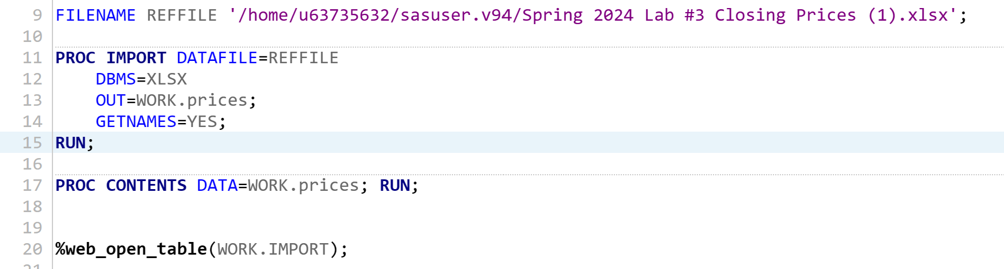
02
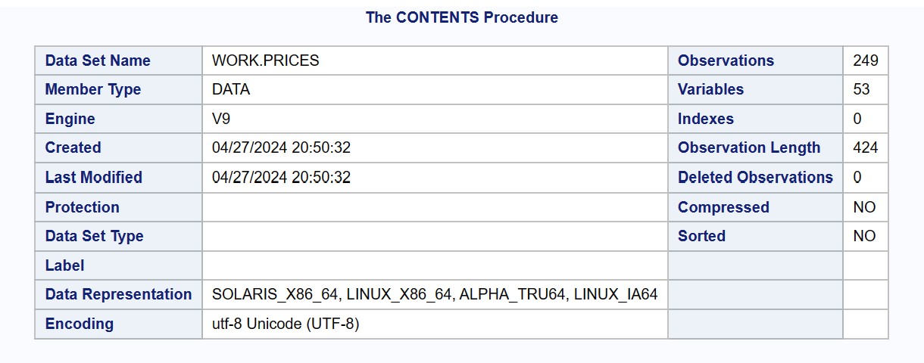
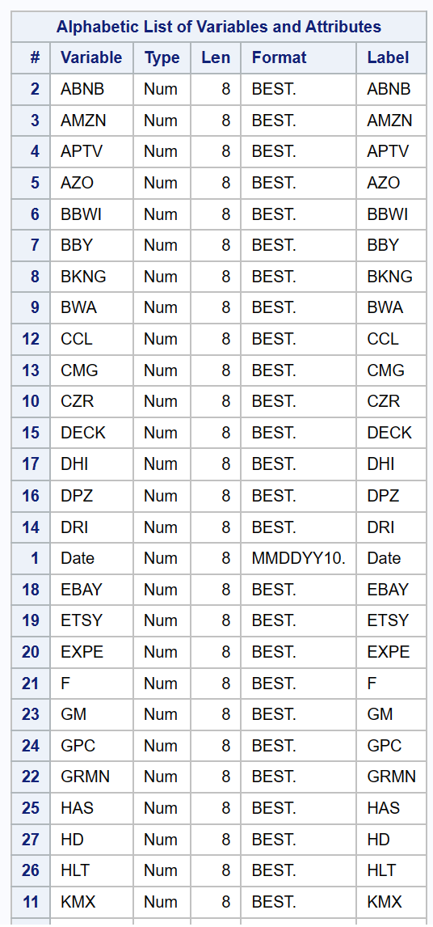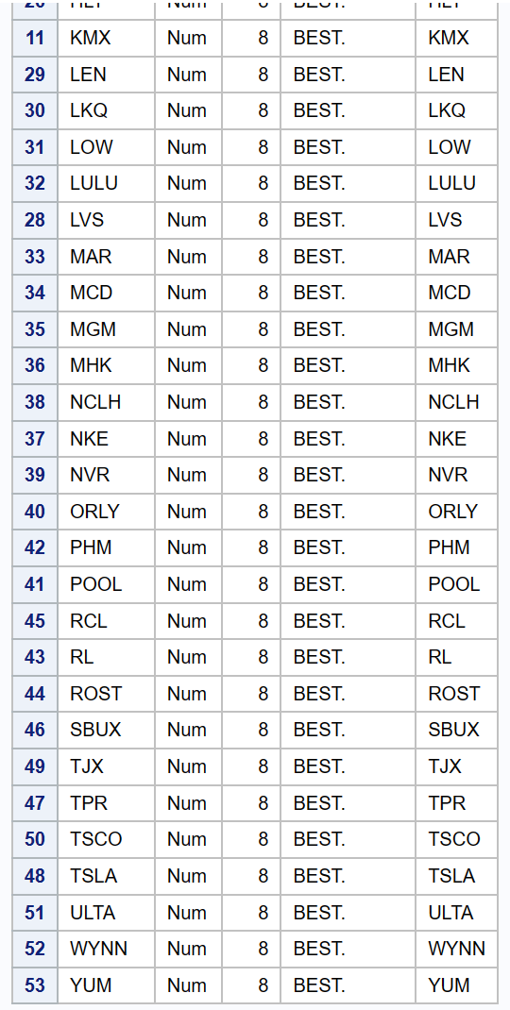
03
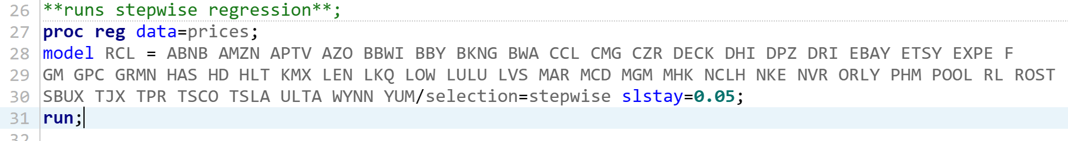

04
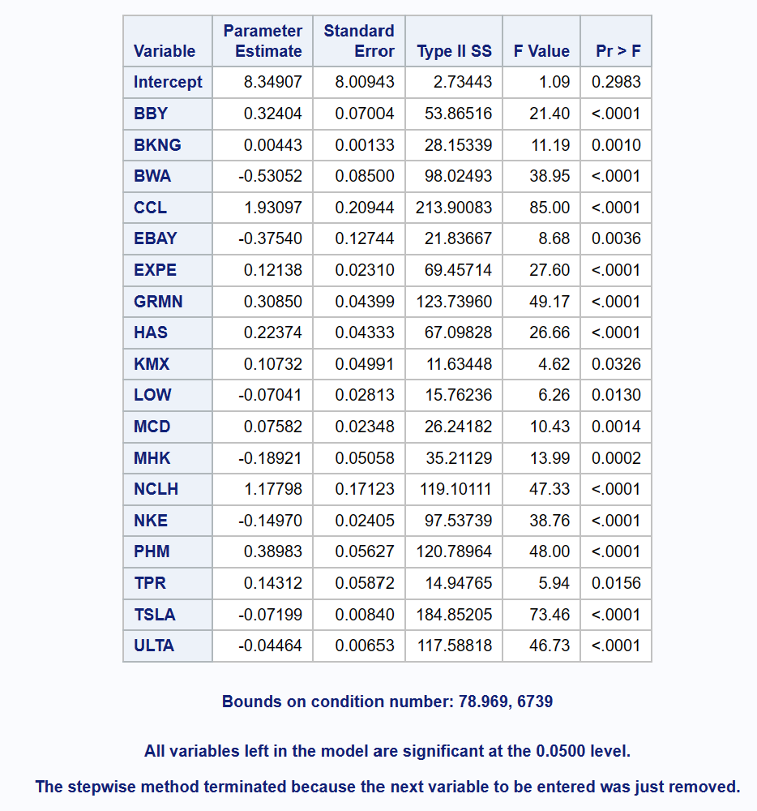
05
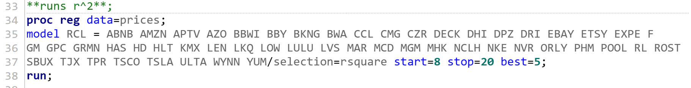

06
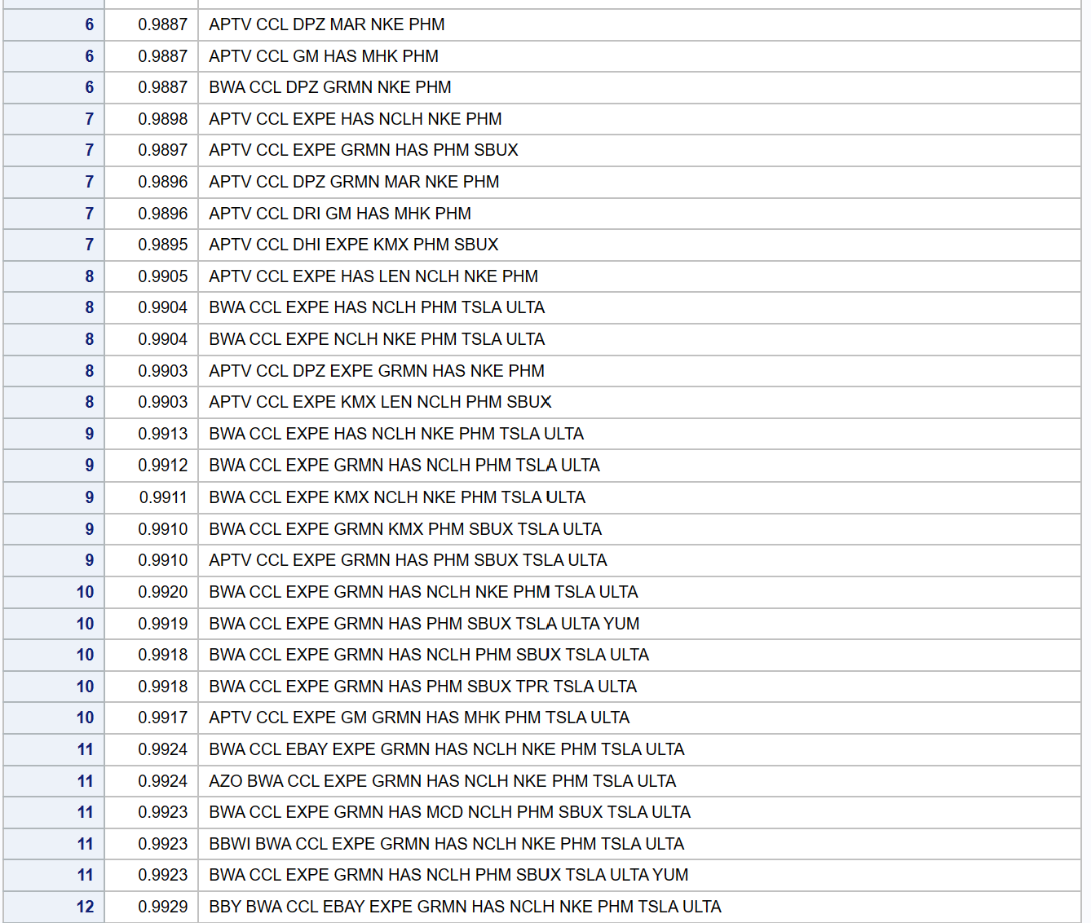
07
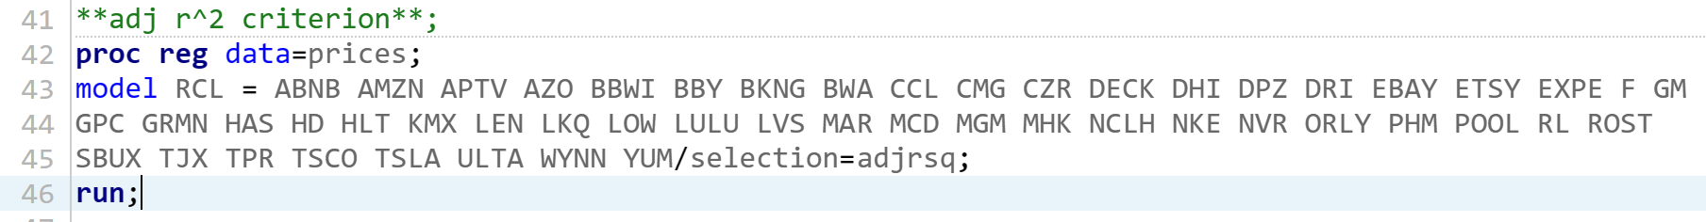

08
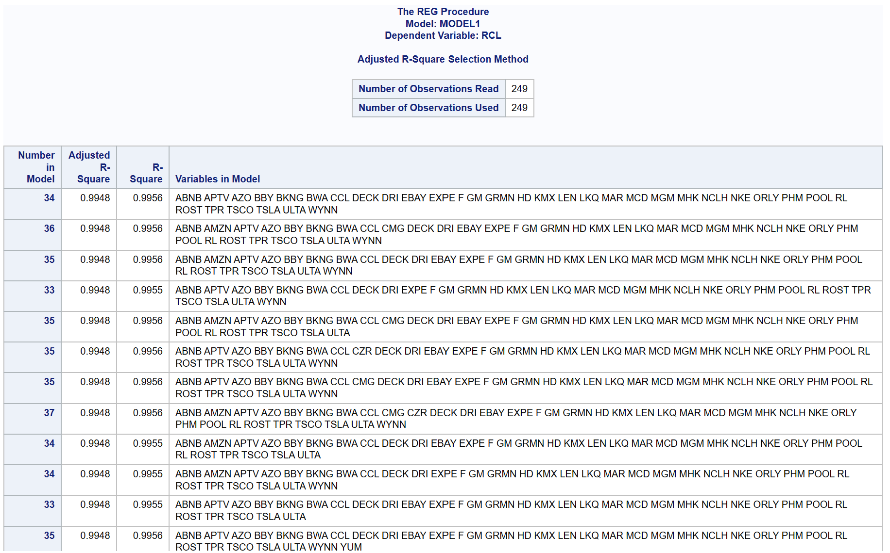
09
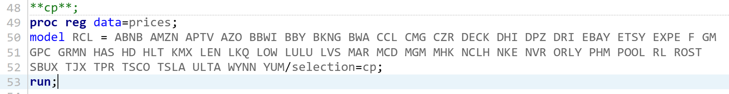
10
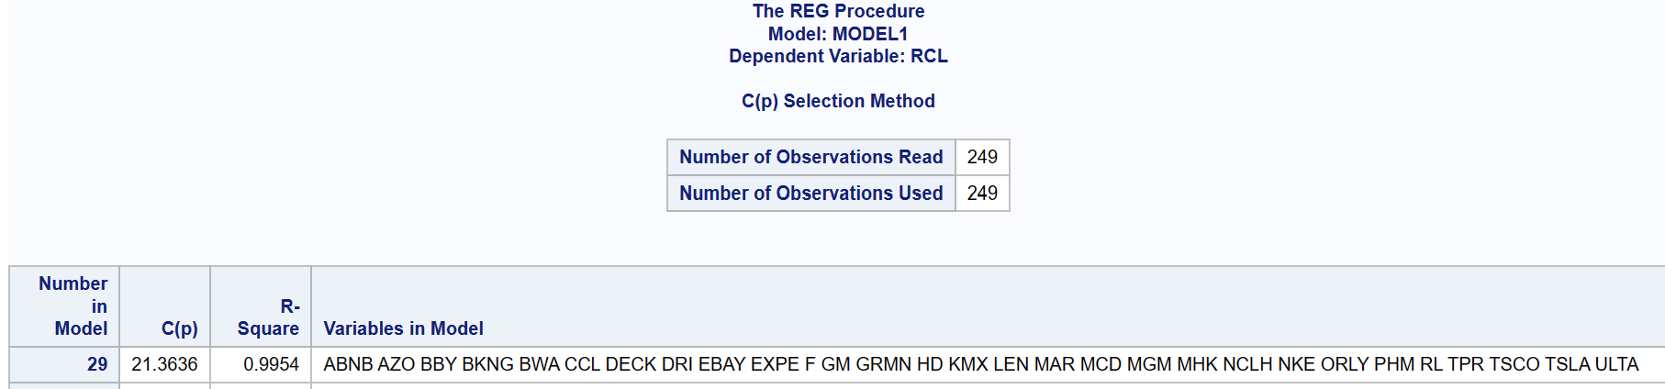

11
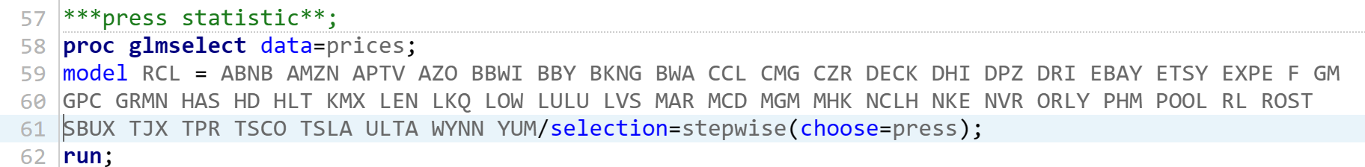
12
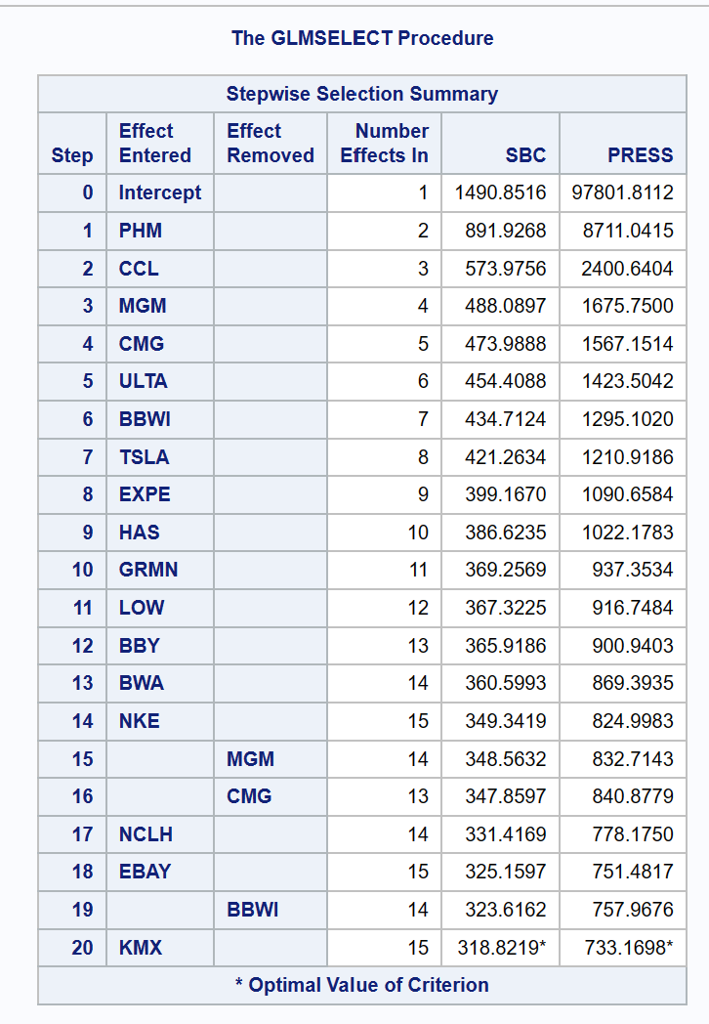

13
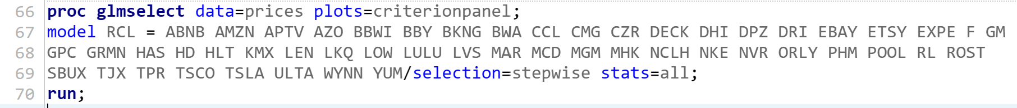
14
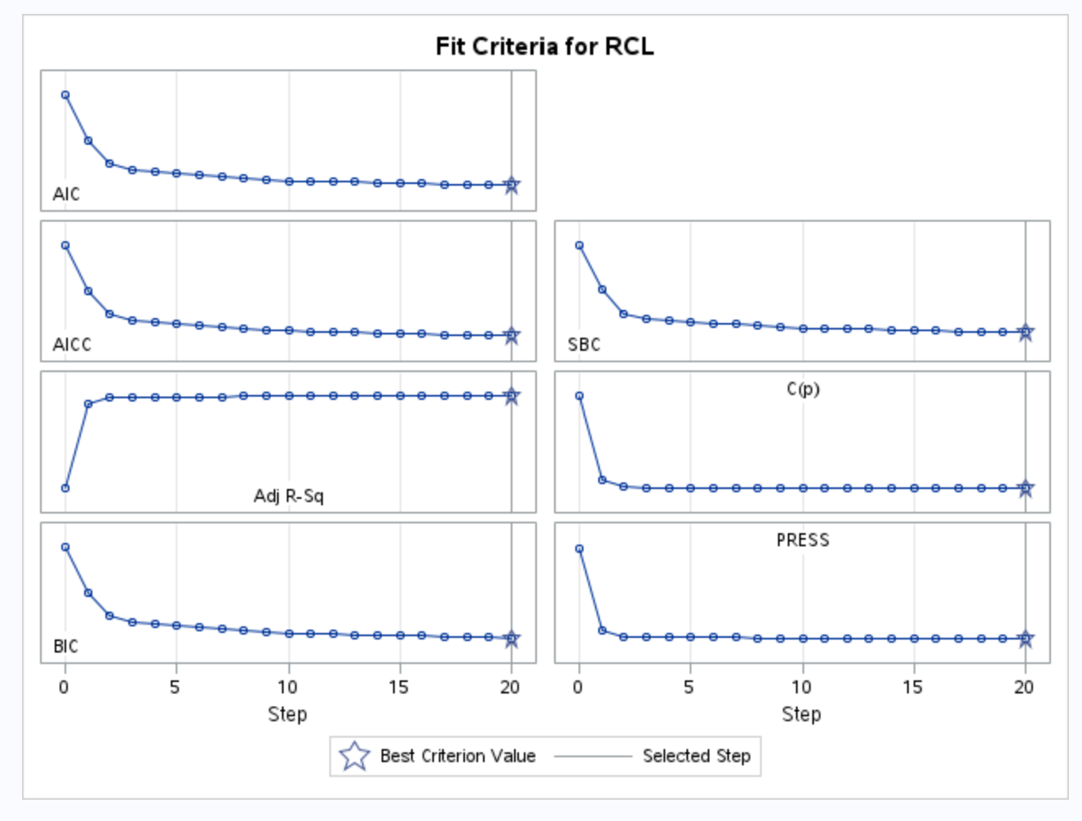

15
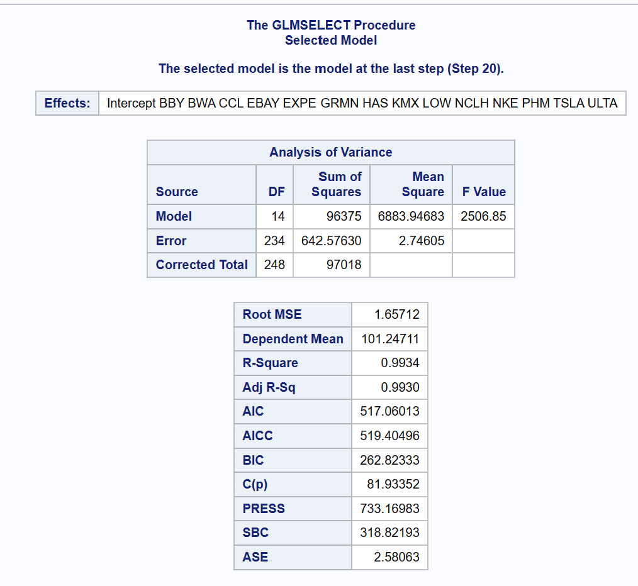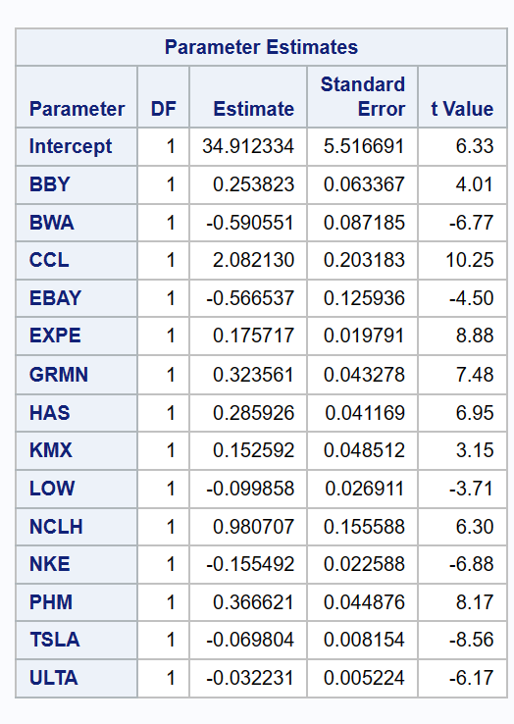
16
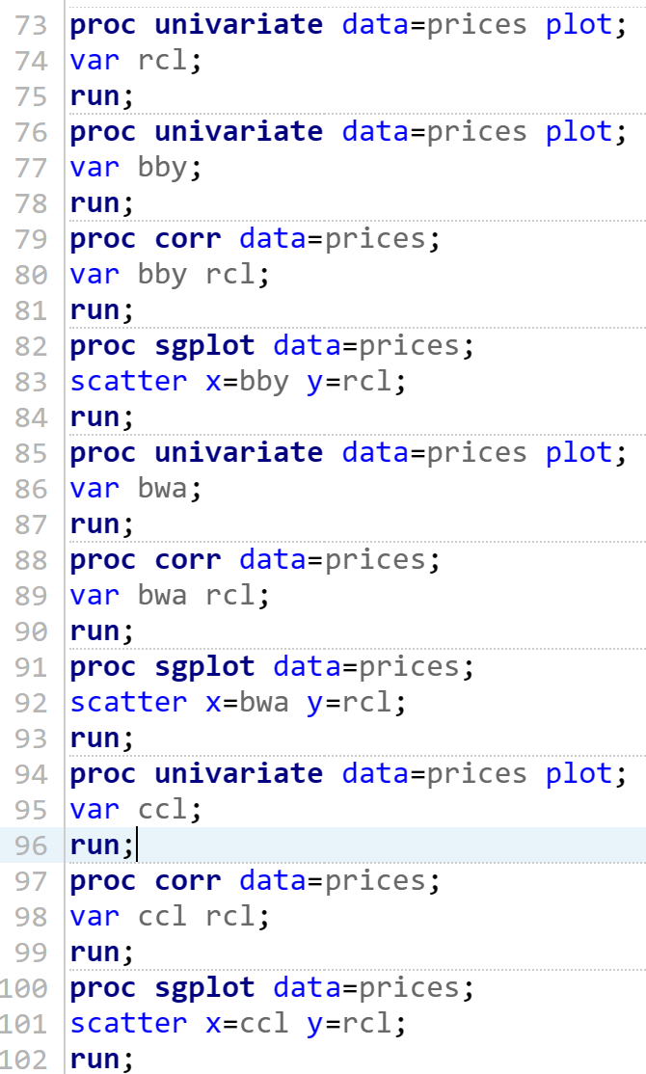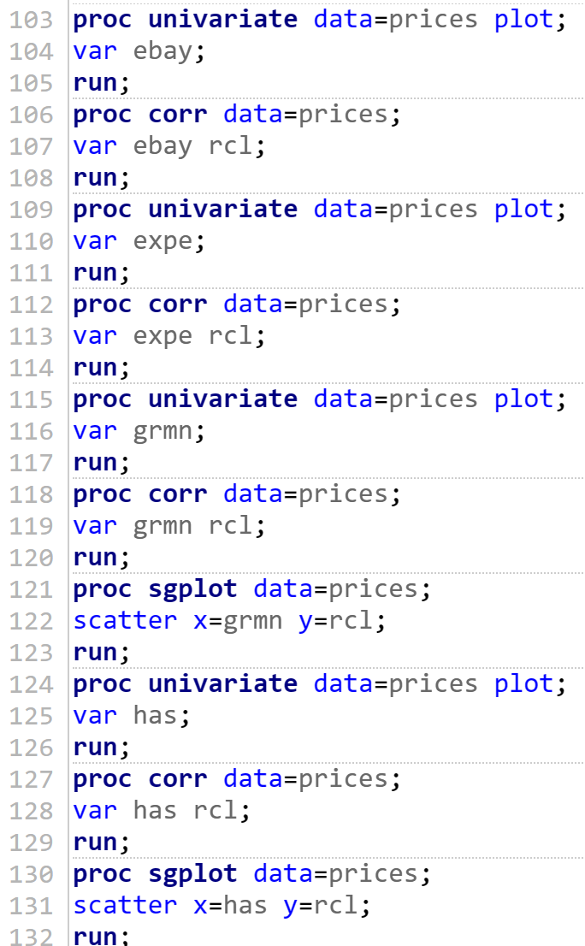
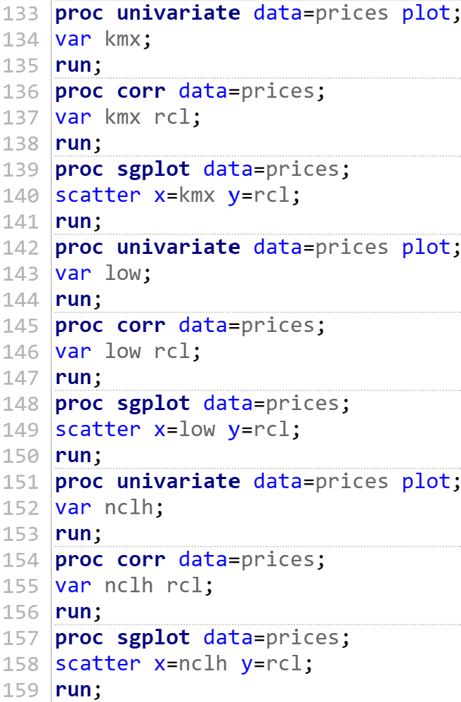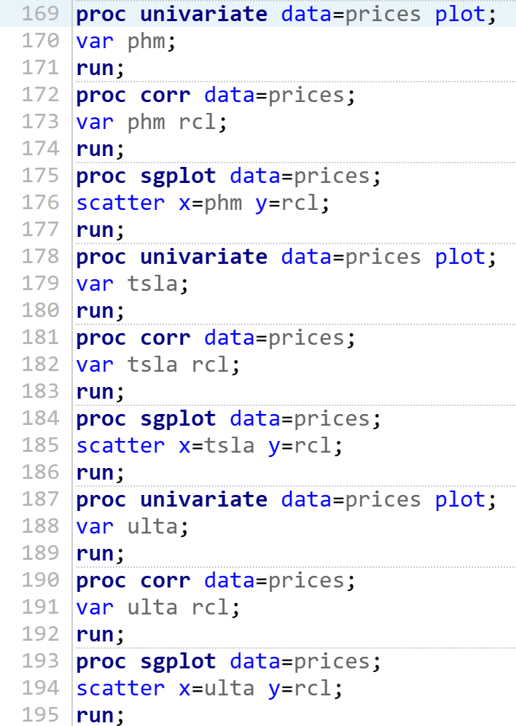
17
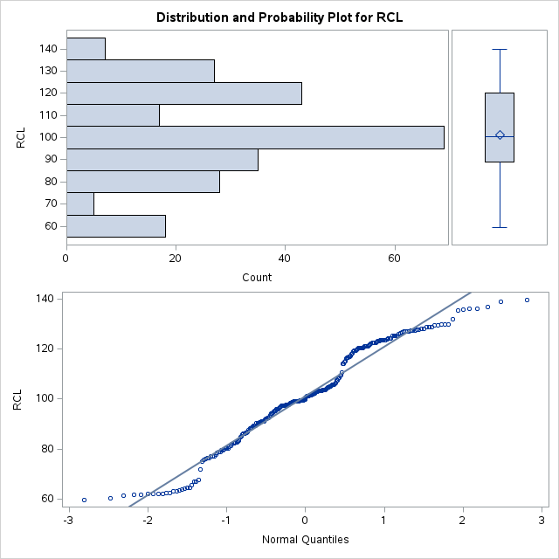
18
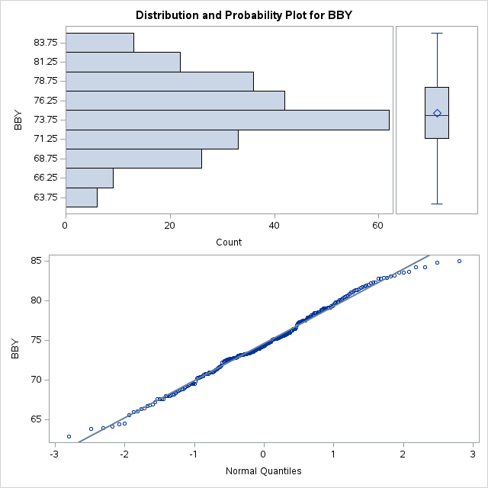
19
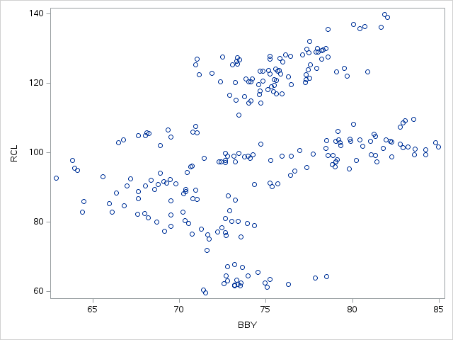
BBYR
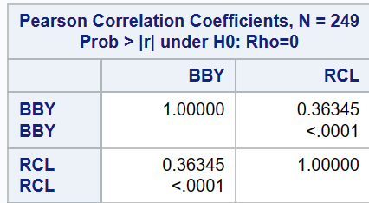
20
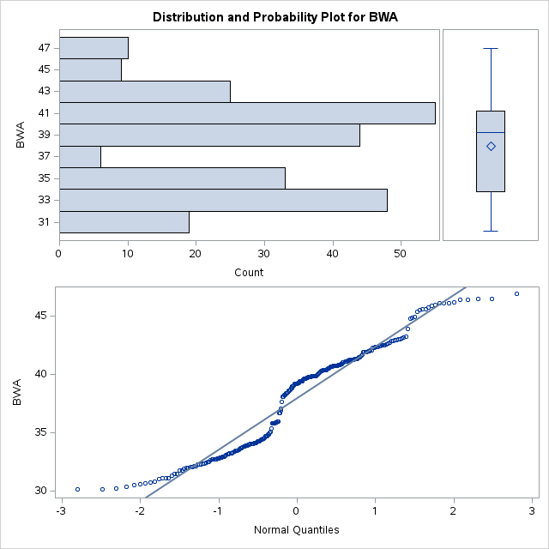
21
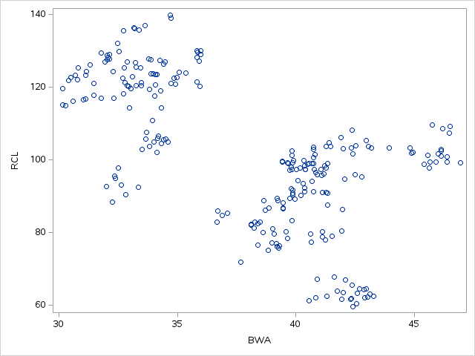
BWAR
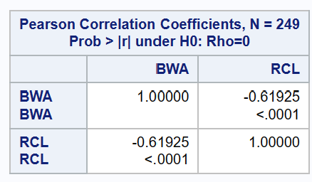
22
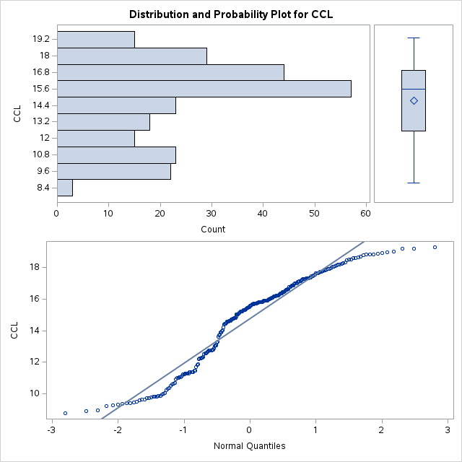
23
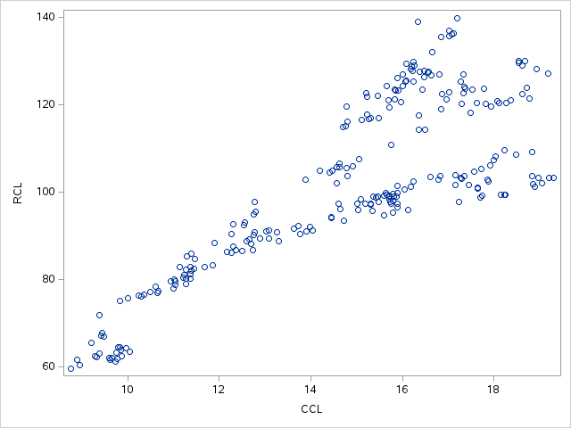
CCLR
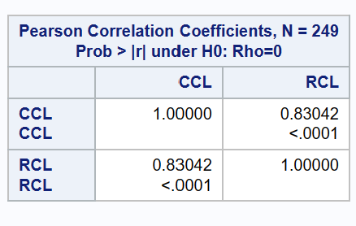
24
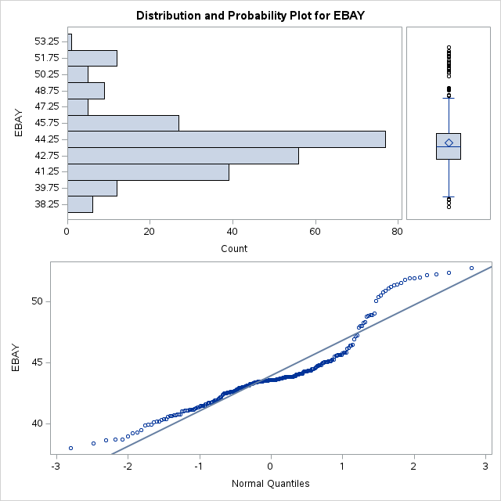
25
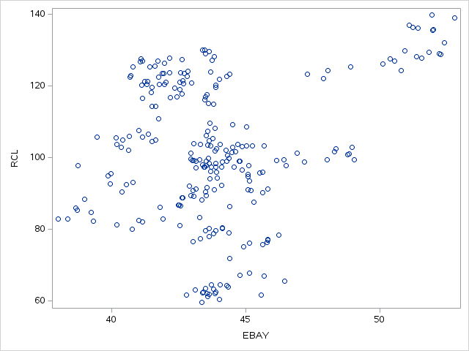
EBAYR
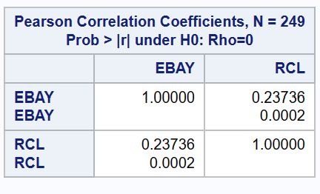
26
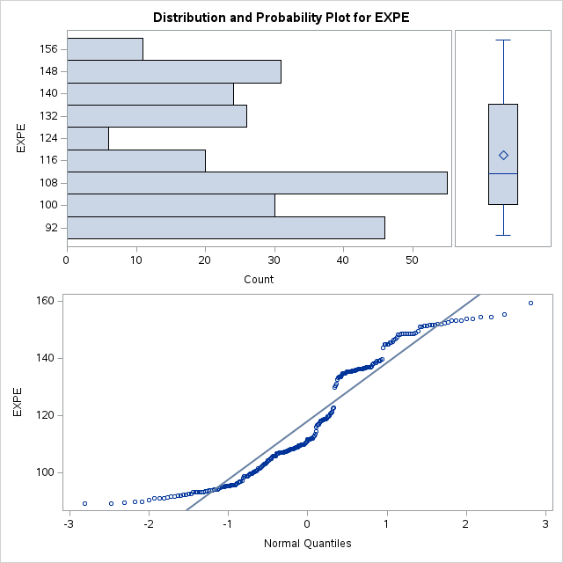
27
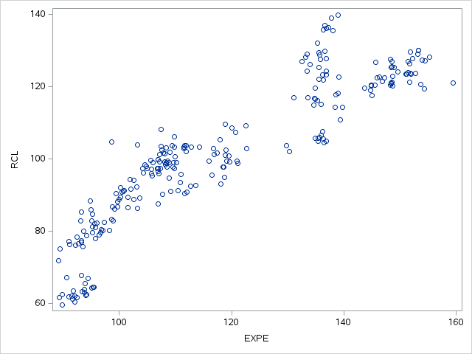
EXPER
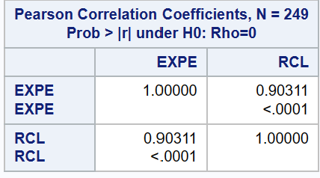
28
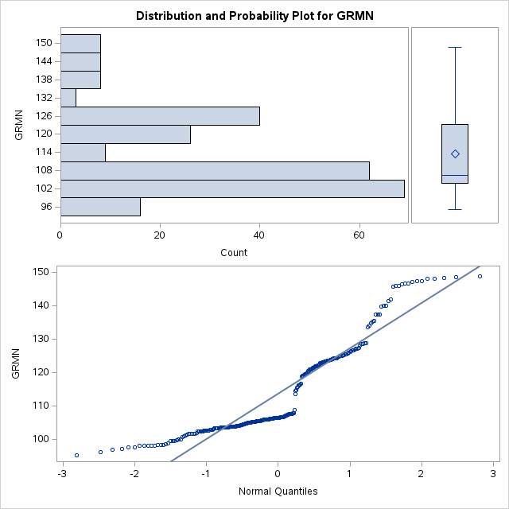
29
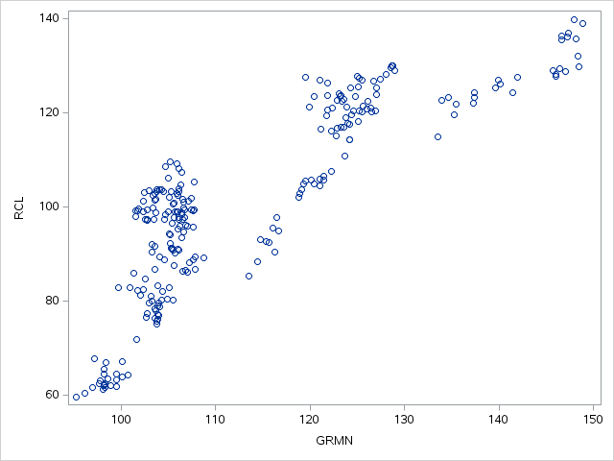
GRMNR
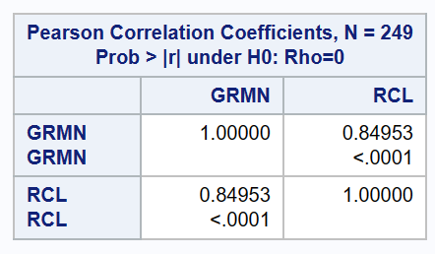
30
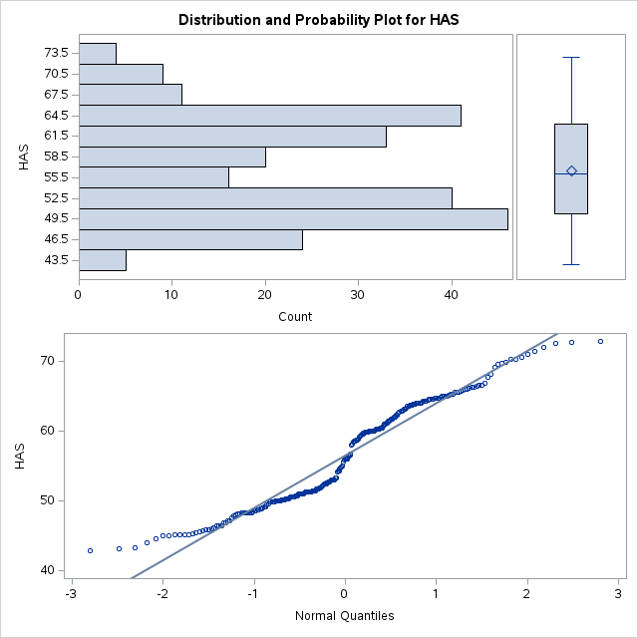
31
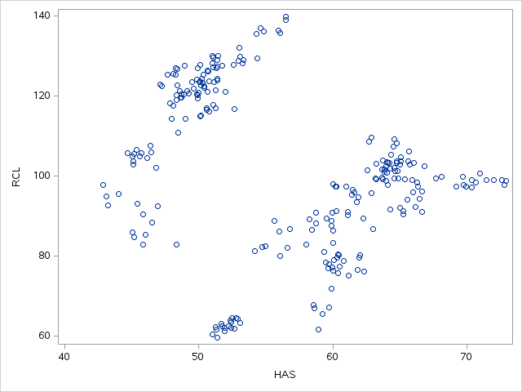
HASR
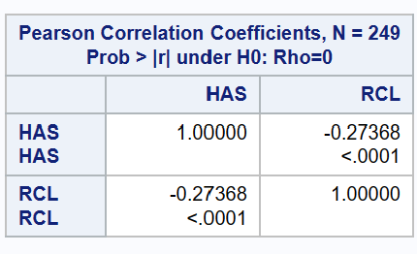
32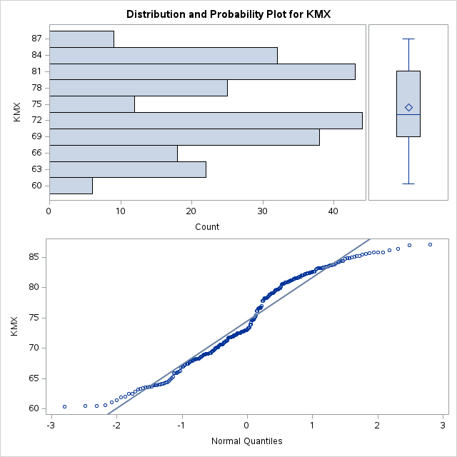
33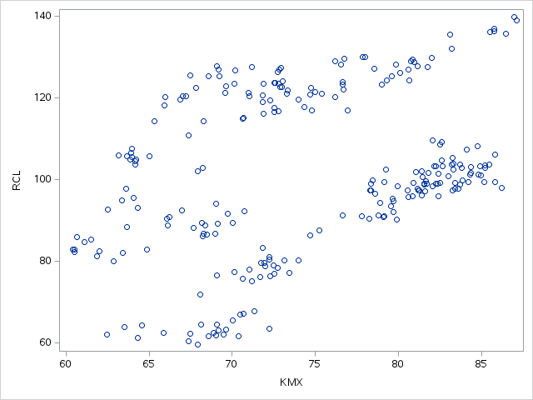
KMXR
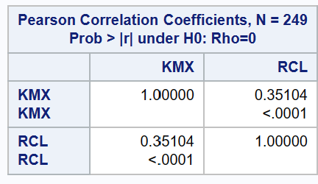
34
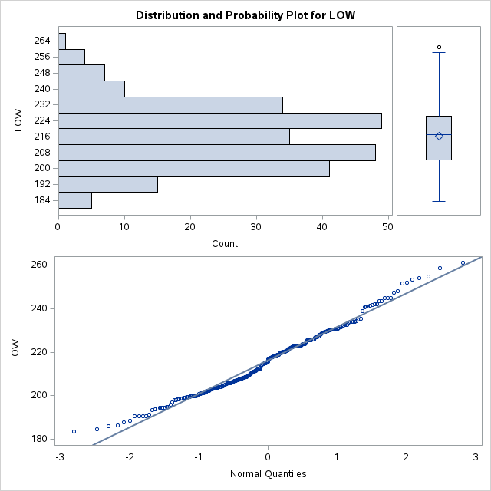
35
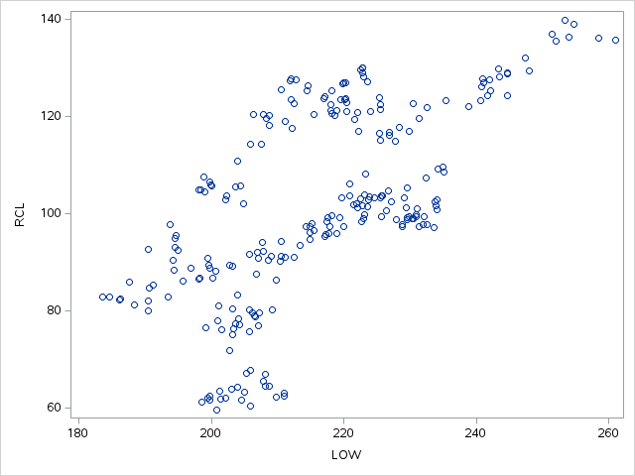
LOWR
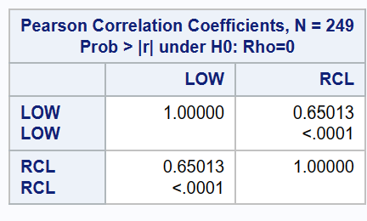
36
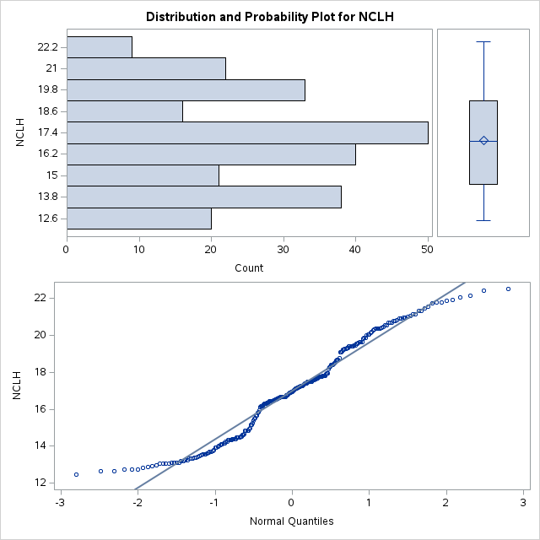
37
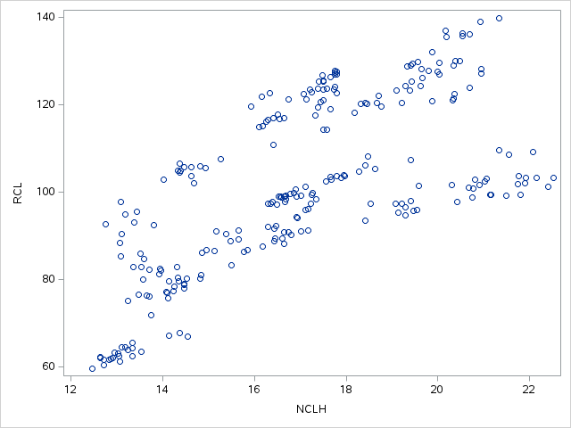
NCLHR
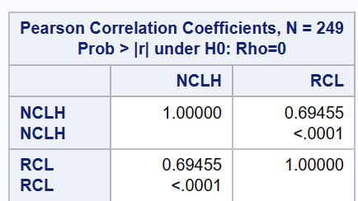
38
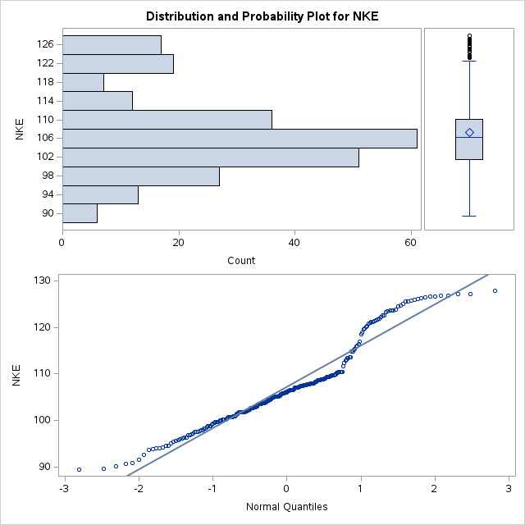
39
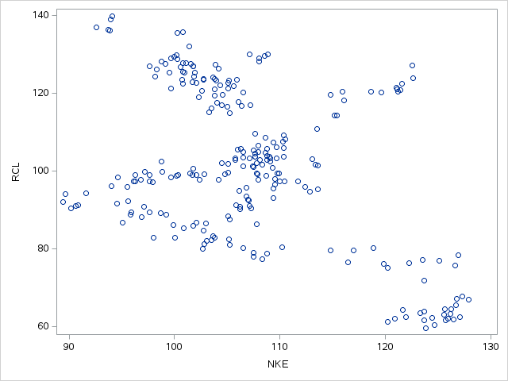
RNKE
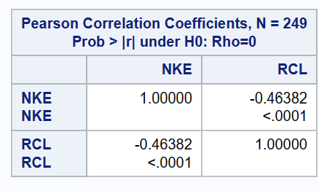
40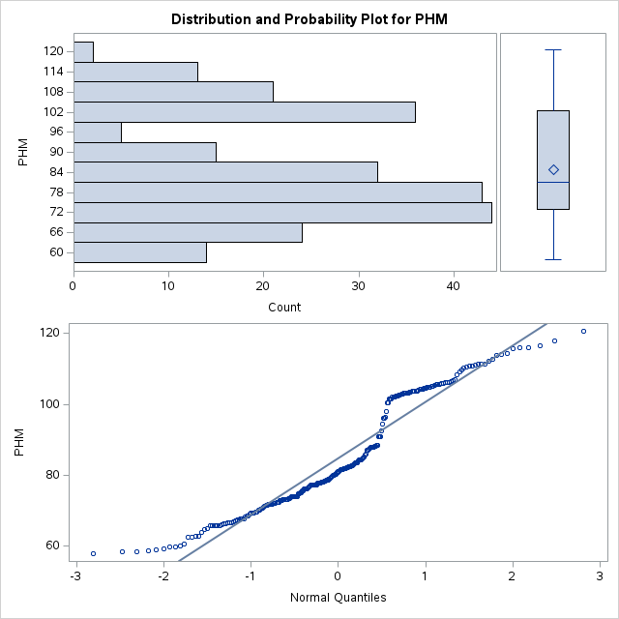
41
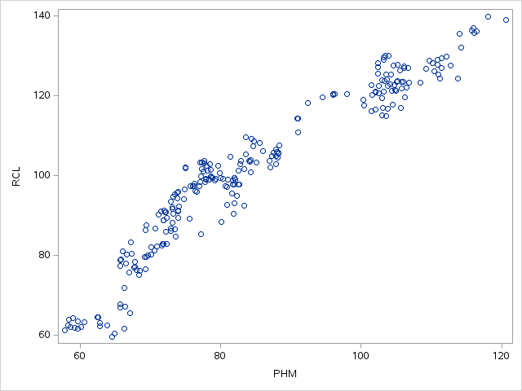
PHMR
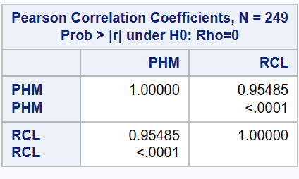
42
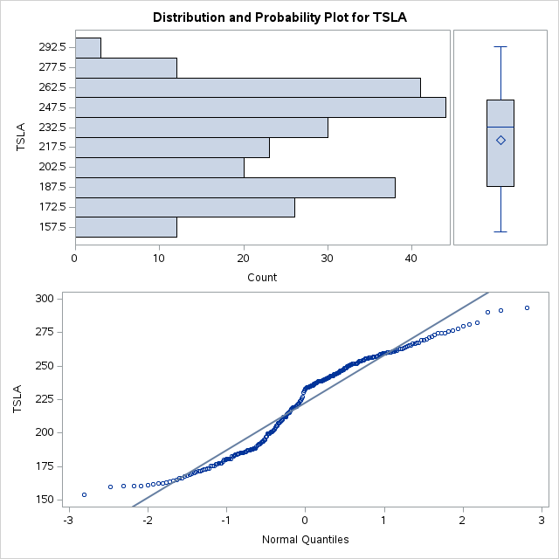
43
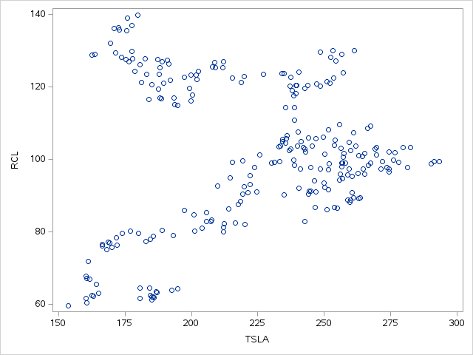
TSLAR
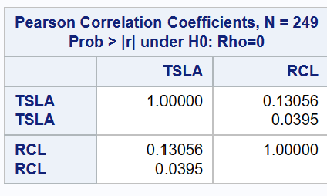
44
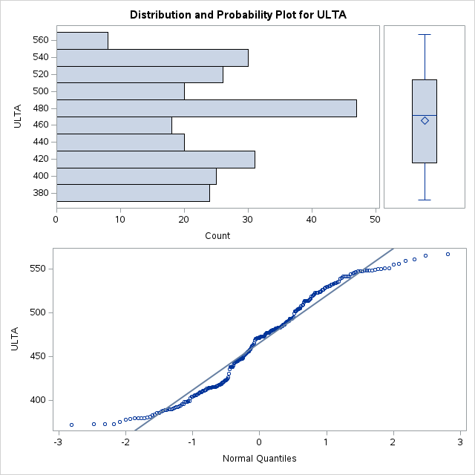
45
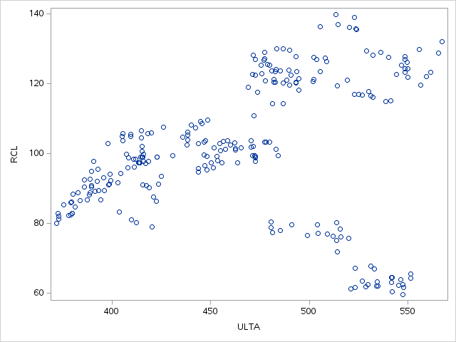
ULTAR
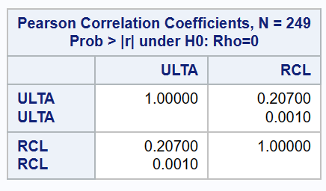
46
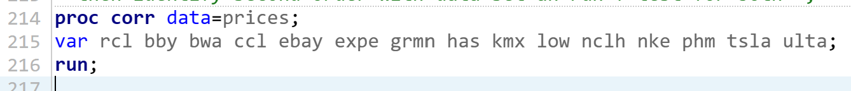

47
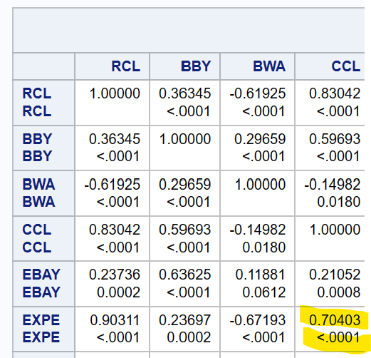
48
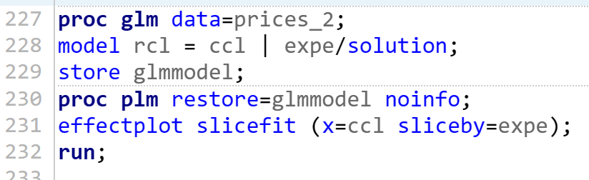
49
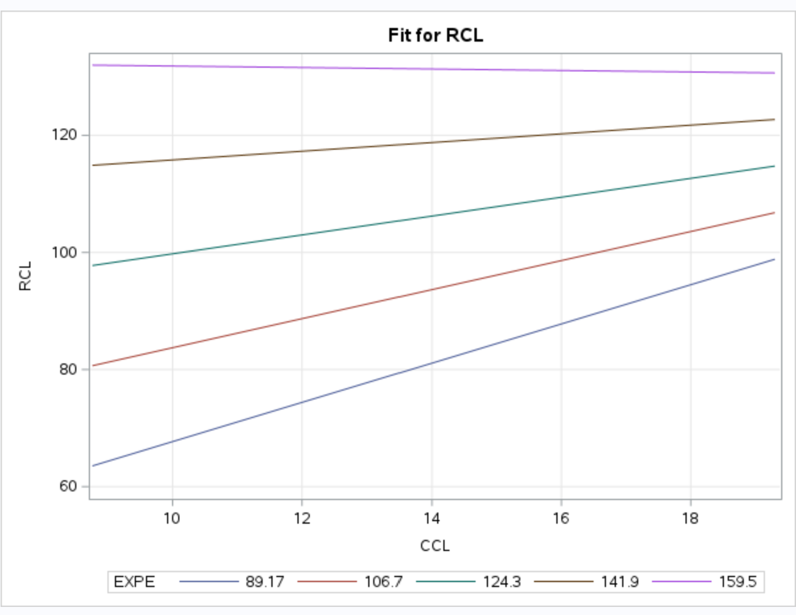
50
51
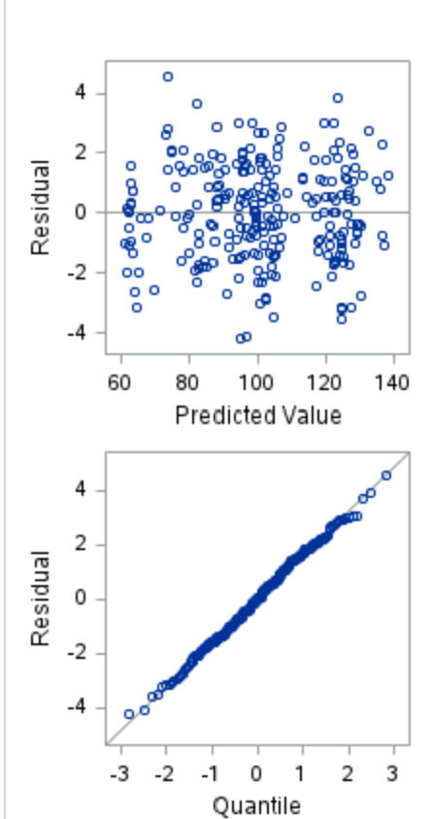
52
53
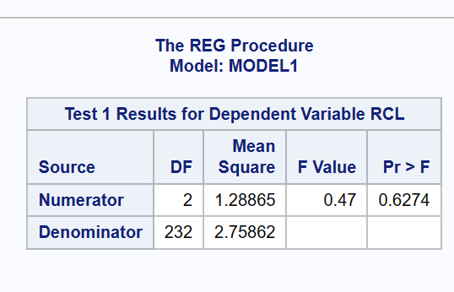
54
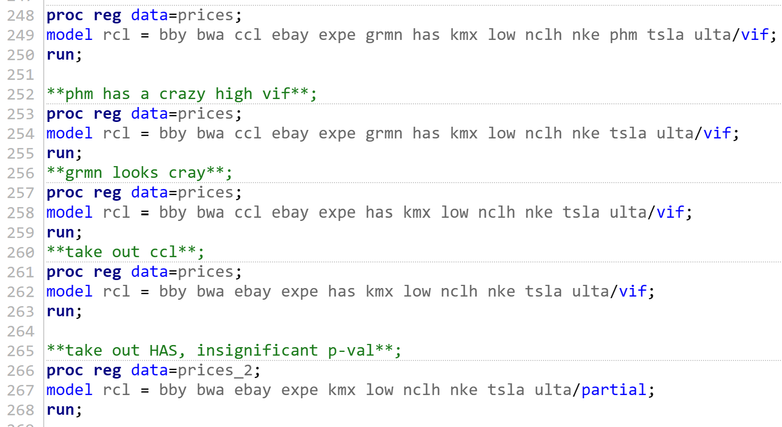
55
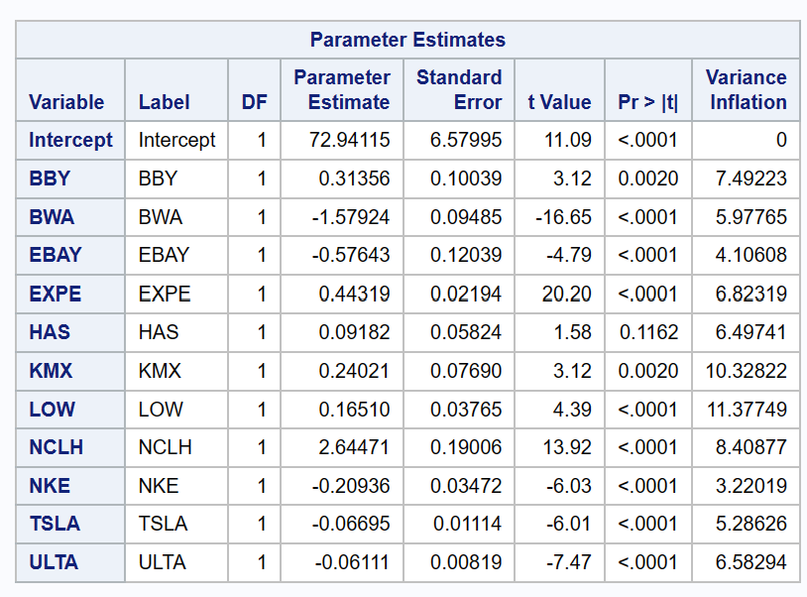
56
57
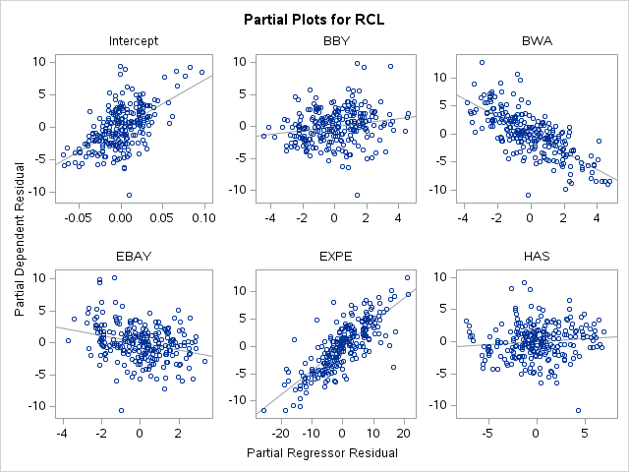
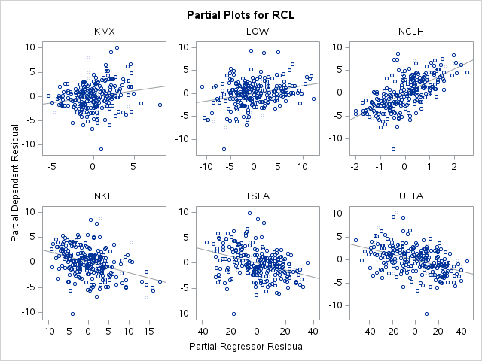
58
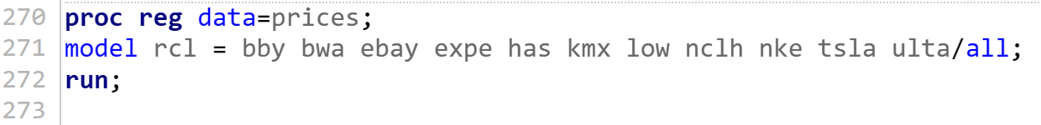
59
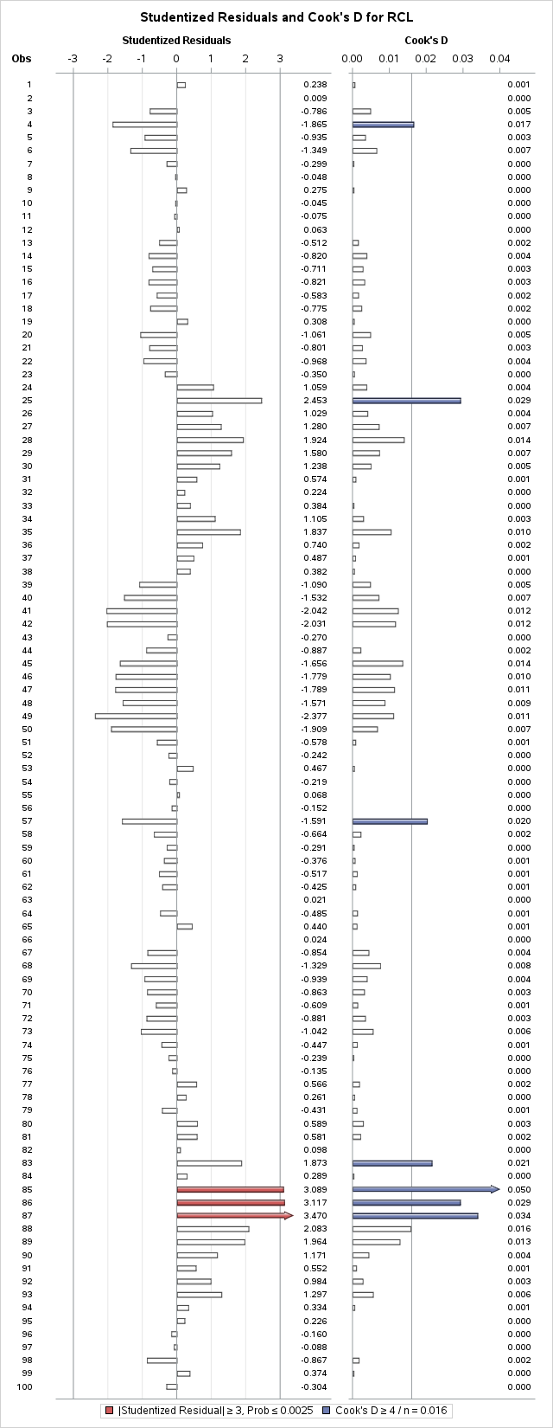
60
